data engineer:

a data enginner designing, building, and maintaining the architecture of an organization's data infrastructure.

data infrastrucutre includes steps like

collecting data,converting data, sttoring data in targert system,creating system to access data and securing data

data analyst :

uses the data made by data engineer to extracting insights and value from data to answer business questions and some analyst also cleans the data and create dashboard

data scinentist:

would develop a predictive model using machine learning algorithms to forecast the future from the past data

right?

r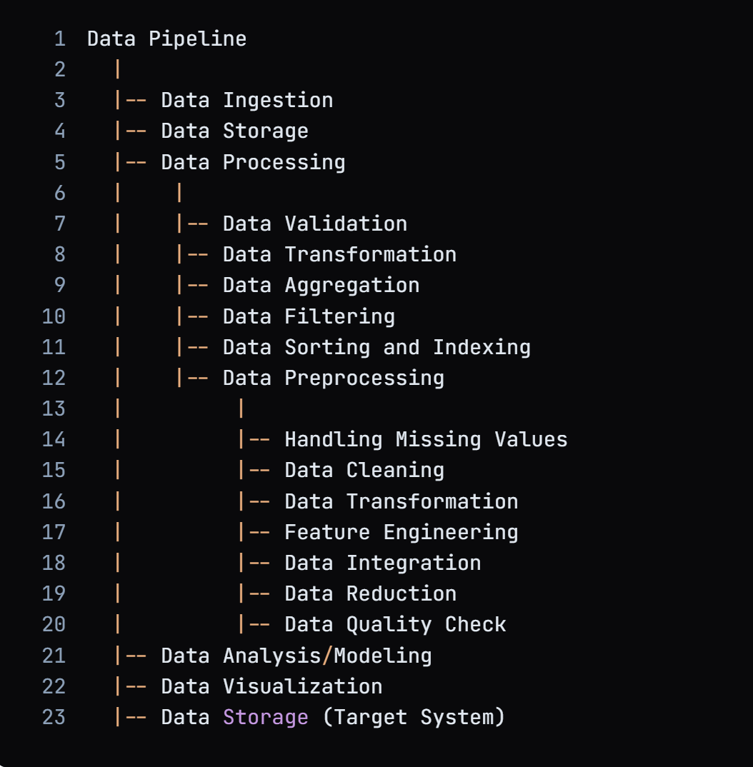

this image is for real time process for static process the data analysis and data storage part is removed

so final data infrastrucutre and data pipeline has same process only data infrastrucutre has addition process of data security and generating system to fetch data ,data pipeline involves process of data ingestion,data storage,data processing,data preprocessing(if required) data storage in target system after that the data is taken by user and data preprocessing is applied as per the requirement and analysis,visualization and machine learing is done accordingly

**Scenario 1: Data Processing + Data Preprocessing → Storage → Analysis/Visualization/Machine Learning**

**Scenario 2: Data Processing → Storage → Data Preprocessing → Analysis/Visualization/Machine Learning**

**Scenario 3: Data Processing → Storage → Analysis/Visualization/Machine Learning (no preprocessing)**

**Module 2(Data wrangling)**

**P1.1 we will discuss how data is stored,moved and placed in tables**

**P1.3 tip1plan for what you will be using data for (if you Want to use math problem don’t store it in stirng)**

**Tip2 important to pick the right size**

**Int data type link** [**https://phoenixnap.com/kb/mysql-data-types**](https://phoenixnap.com/kb/mysql-data-types)

|  |  |  |  |  |  |
| --- | --- | --- | --- | --- | --- |
| 1 | 6 | 15:52:39 | alter table trial add column bol double(6,3) | 0 row(s) affected, 1 warning(s): 1681 Specifying number of digits for floating point data types is deprecated and will be removed in a future release. Records: 0  Duplicates: 0  Warnings: 1 | 0.015 sec |

